UXP-jQuery-L2-0001: jQuery User Registration Form

Level: L2

Technologies: jQuery, HTML5, Css3, Bootstrap**.**

Case Study: To Create Registration Form with form validation.

**Tips to start**

**Case Study – jQuery User Registration Form**

Visual:

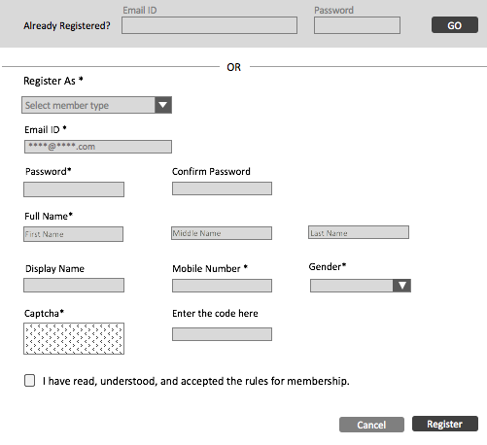

Error page:

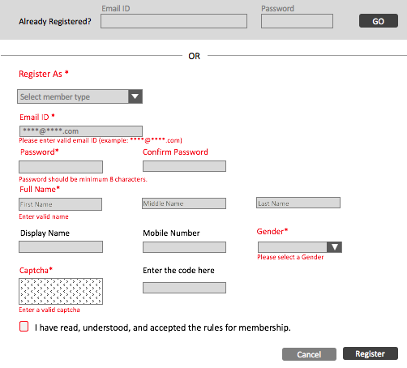

**Getting Started:**

Bootstrap your HTML page, create a HTML5 page with CSS3 and form validation with help of jQuery.

**Dependencies:**

Develop html page using bootstrap framework and apply form validation with jQuery. Refer the links below.

Bootstrap: <http://getbootstrap.com/>

jQuery library: https://jquery.com/download/

**Additional notes:**

* Create a table in HTML5.
* Create a Form with the fields as shown in the Picture above.
* Use placeholders for the input fields.
* <table><tr><td> should not be used.
* Table should be responsive in all devices.
* Include the jQuery library latest version.
* Error page should be as shown in the visual.
* Email, phone number validation should be checked.